

**COMP6231- Distributed System Design**

**Project**



**Date:** 12 August 2020.

**Recipient:** Prof. Mohammed Taleb

**Student Name:** Raj Mistry (40119206)

* **Introduction:**

To implement a highly available CORBA Distributed Player Status System, which tolerates software failure (non-malicious Byzantine) using active replication. There are three replicas which contains a copy of each 3 servers. One of the replicas works as a leader, which takes all the request from client and will send it to all other replicas using FIFO broadcast which sends client requests in same sequence order of received operation, then it receives response from them and sends single correct response to client. Also, leader informs Replica Manager about software failure. The servers and replicas communicate via unreliable UDP protocol.

* **System Architecture:**

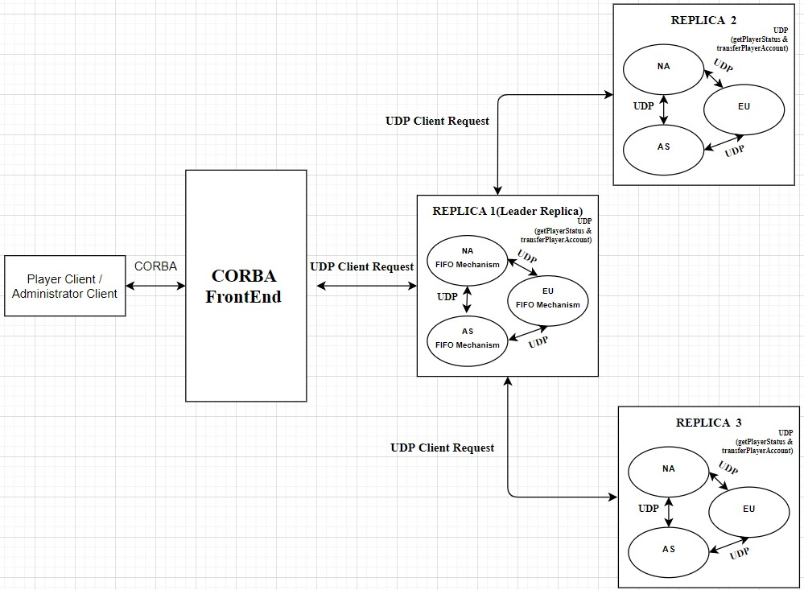

* **UDP (Inter Server Communication):**

The User datagram Protocol is a transport layer protocol. It is connectionless and unreliable protocol. To communicate using UDP it is not required to establish connection prior to data transfer. A datagram is an independent, self-contained message sent over the network whose arrival, arrival time, and content are not guaranteed. The Datagram Packet and Datagram Socket classes in the java.net package implement datagram communication using UDP.

* In this assignment I have implemented UDP for communication among three servers (NA, EU and AS) in order to perform operations getPlayerStatus() and transferAccount(). Each server Creates its own UDP thread when server starts.
* In getPlayerStatus () the current server communicates with other servers using UDP request “GETSTATUS” to fetch the player accounts status on corresponding server and returns server specific online and offline player accounts count. (In this UDP request will be sent to rest of the 2 servers)

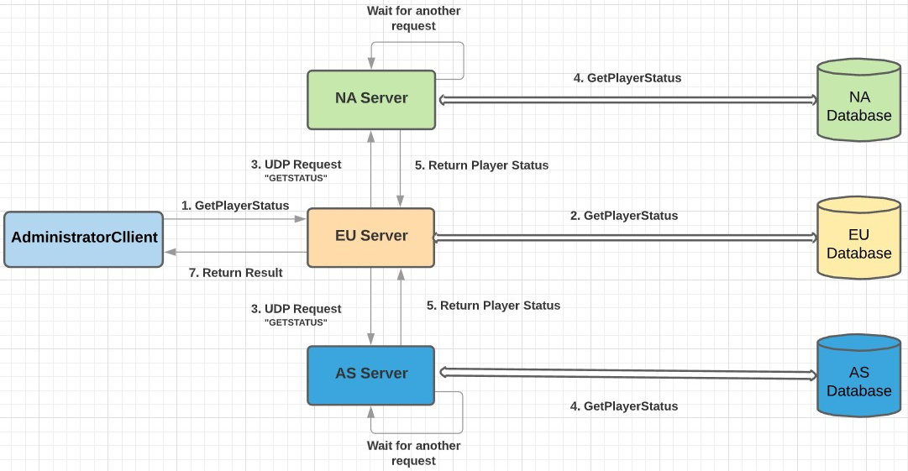

* In transferAccount() checks the HashMap for the required player account. If found, the server transfers the account to specified remote server by sending UDP request “TRANSFERACCOUNT” and after successfully transferring the record to remote server, it will remove the record from its storage and then server informs the client that the player account transfer is successful.(In this UDP request will be sent to only 1 server where we want to transfer Player Account[Destination Server] e.g. To transfer Account from EU to AS, UDP Request will be sent to AS only not to NA])

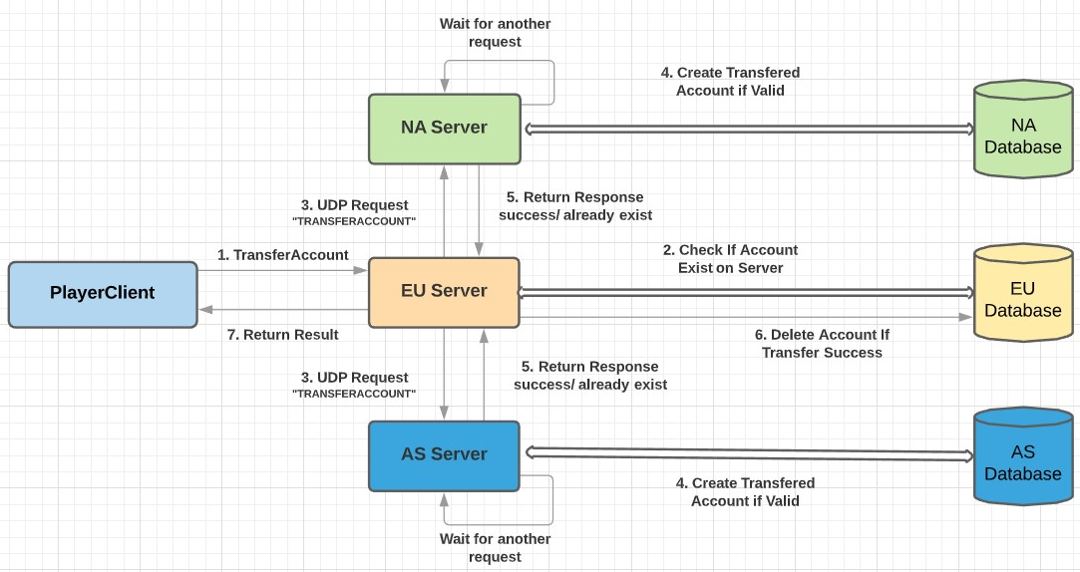

* **Class Diagram:**

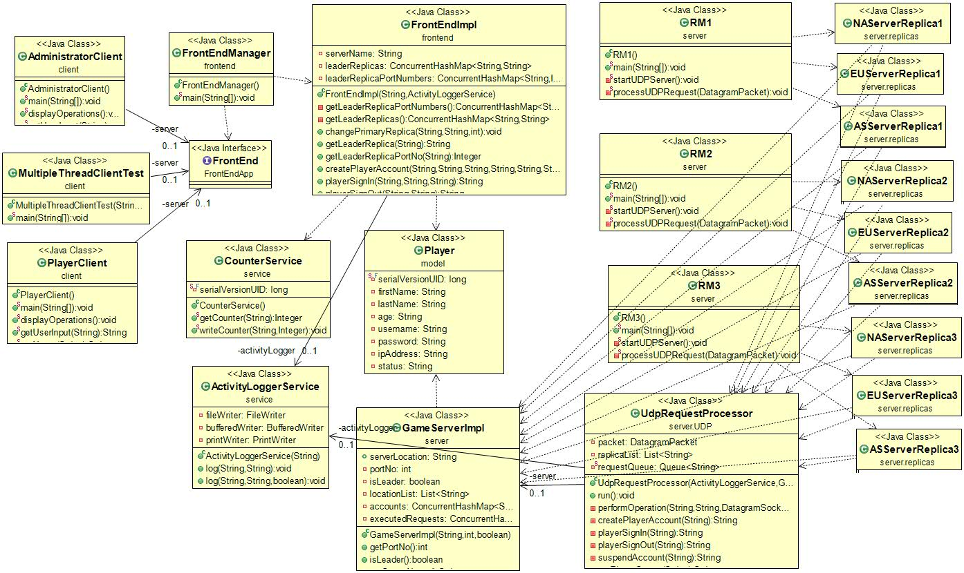

* **Classes Description:**
* **PlayerClient.java , AdministratorClient.java & MultipleThreadClient.java:**

These are the client classes which communicates with FrontEnd through CORBA. Player Client can perform 4 operations and Admin client can perform 2 operations which are: createPlayerAccount, playerSignIn, playerSignOut, transferPlayerAccount, getPlayerStatus and suspendPlayerAccount. From the client’s end, the whole system’s functionalities are encapsulated while the complexities are hidden from the end users.

* **FrontEnd.java:**

Thisis an interface which declares below methods that client can invoke

* String createPlayerAccount (String firstName, String lastName, String age,

String username, String password, String ipAddress);

* String playerSignIn (String username, String password);
* String playerSignOut (String username);
* String transferAccount (String username, String password, String

newIpAddress);

* String getPlayerStatus ();
* String suspendAccount (String usernameToSuspend);
* **FrontEndImpl.java:**

This Class implements all the operations of FrontEnd interface. When client wants to perform any operation, it will send the request to FE through CORBA. FE will generate request id and append it to request and send it to appropriate server in Leader Replica.

* **NAServerReplica1/2/3 .java, EUServerReplica1/2/3 .java, ASServerReplica1/2/3 .java:**

These are the server classes which can work leader as well as normal server. The only difference between leader and normal server is one Boolean Value “isLeader” set true or false. Each server replica will start its own UDP server. In order to start all these server replicas, we need to run their respective Replica Manager (RM) java files.

For starting Replica 1 servers run: **RM1.java**

For starting Replica 2 servers run: **RM2.java**

For starting Replica 3 servers run: **RM3.java**

* **GameServeImpl.java:**

This class is used to perform all the operations at server side. It contains implementation of all the client operations.

* **CounterService.java**

This class is serializable class used to generate the request id for client requests coming at FE and it keeps id unique among all servers. This class will read latest counter from

*RequestCounter.txt*

* **Player.java (Model):**

This is a java bean class to hold following data of players, First Name, Last Name, Age, Username, Password, Status and Ip Address.

* **FIFO Mechanism**

Whenever FE sends client request to Leader replica, it will add that request into FIFO queue. Here I have used *ConcurrentLinkedQueue* data structure to create FIFO queue as it is more thread safe in multithreading environment. Leader replica will peek head request from the queue and perform the operation and simultaneously it will multicast that request to other 2 replicas through UDP, after receiving response from other replicas leader replica will compare all the responses including its response and will send correct single response to FrontEnd.

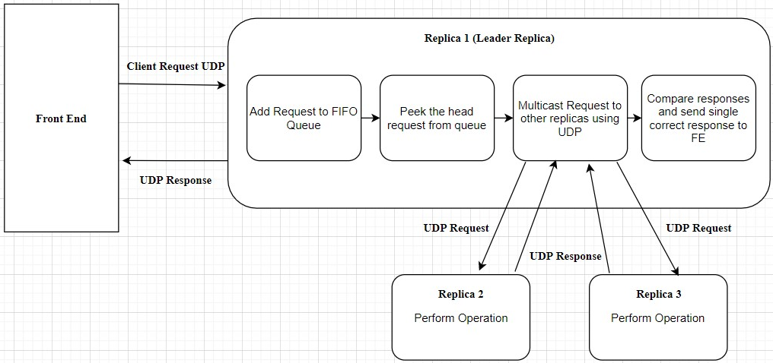

* **UDP Reliability**

In this project I have used socket timeout and maximum 3 attempt to perform any operation to make the UDP reliable. While sending UDP request I have set socket timeout of 5 seconds, so that sender server will wait for 5 seconds for getting response and after that it will throw timeout exception. In socket timeout exception code block I have decreased the attempt count and resend that request. This process will repeat 3 time as maximum attempts are set to 3. This will help UDP server to maintain its reliability and avoid one UDP call of sending acknowledgement from destination server to source server which in turn reduce the delay of UDP calls.

* **Data Structures:**
* **Account Storage:**

Here in this assignment in order to improve concurrency I have used ConcurrentHashMap to as the storage for Player Accounts as it is an enhancement of HashMap, as we know that while dealing with threads in our application simple HashMap is not good choice because performance wise HashMap is not up to the mark. ConcurrentHashMap class is thread safe and it is good choice when we need high concurrency in our application. It does not throw a “ConcurrentModificationException” if one thread tries to modify it while another is iterating over it.

**Syntax:**

**ConcurrentHashMap<String, List<Object>> accounts = new**

**ConcurrentHashMap<String, List<Player>>();**

* **FIFO Mechanism**

I have used *ConcurrentLinkedQueue* in order to create FIFO queue as it is more thread safe in multithreading and concurrent process environment.

**Syntax:**

**Queue<String> requestQueue = new *ConcurrentLinkedQueue<String>();***

* **Response History**

I am maintaining response history at each replica to avoid duplicity of accounts. To achieve this, I have used ConcurrentHashMap data structure.

**Syntax:**

**ConcuurentHashMap<String, String> executedRequests = new ConcuurentHashMap <String, String>();**

* **Multithreading and Synchronization:**

Thread is a lightweight process which has its own stack. When Multiple threads try to access the same resources and produces wrong result because of data corruption. This happens because while one thread is accessing resource same time other thread interferes and access it and now both perform operation on that old value and write their result which may produce wrong result.

Synchronization is a procedure in which is used to avoid interference with the other threads and memory consistent errors. The keyword synchronized is used to implement Competition Synchronization which means while one thread is executing the critical region where shared resource is used all the other threads will wait until its execution of critical region finished.

There are Two types of synchronizations used in java:

* Method Synchronization
* Block Synchronization.

***Synchronization Used in this Assignment:***

* Block level Synchronization:
  + A specific part or block of code that is needed to be synchronized is put under its own specific scope.
* Method level Synchronization
  + A specific methods or functions in java is synchronized using synchronize keyword before the method name.
* **Operations:**

1. **Create Player Account.**

* While creating player account first all the attributes will be taken as input from user. During the input it will accept only valid inputs for particular field and if invalid input is given it will keep asking for valid input. The validations (All attributes value must be entered. It can’t be empty & without any whitespaces) for input are:

1. FirstName & LastName must contain only alphabets.
2. Age must be positive integer.
3. Username must start with alphabet & its length must be between 6 characters to 15 characters.
4. Password length must be minimum 6 characters.
5. IpAddress must be from valid ipV4 format & it should be from one of these range: 132.xxx.xxx.xxx, 182.xxx.xxx.xxx & 93.xxx.xxx.xxx.

* Once all the valid inputs are entered & Player Account with username does not already exist then it will be added to HashMap with Capital-letter of username’s first character as Key.
* Message will be return to user as well as it will be written in Log Files.

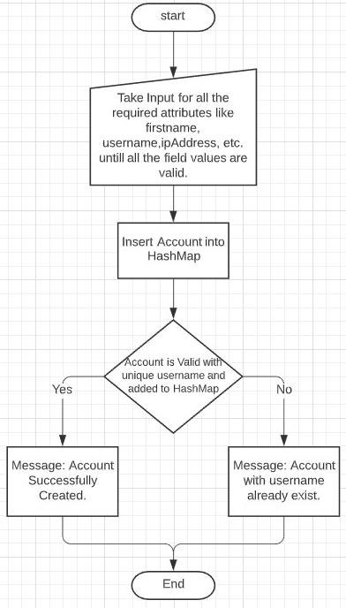

1. **Player Sign In.**

* While client want to sign in into player account program will take username, password and valid IpAddress as input. Then on the server first it will check if there exist a player account with entered username or not. If there is no such a player account with that username it will return message that player account not exist. Otherwise if player account exist it will verify password and if password is correct it will check status and set it online if it’s not already online and based on actions it will return success or error message. Message will be return to user as well as it will be written in Log Files.

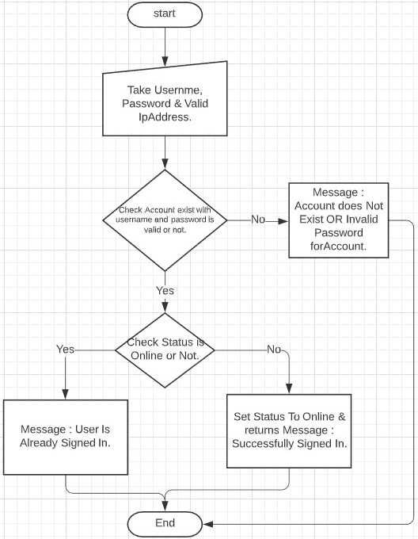

1. **Player Sign Out.**

* While client want to sign out from player account program will take username and valid IpAddress as input. Then on the server first it will check if there exist a player account with entered username or not. If there is no such a player account with that username it will return message that player account not exist. Otherwise if player account exist it will check status and set it offline if it’s not already online and based on the actions it will return success message.
* Message will be return to user as well as it will be written in Log Files.

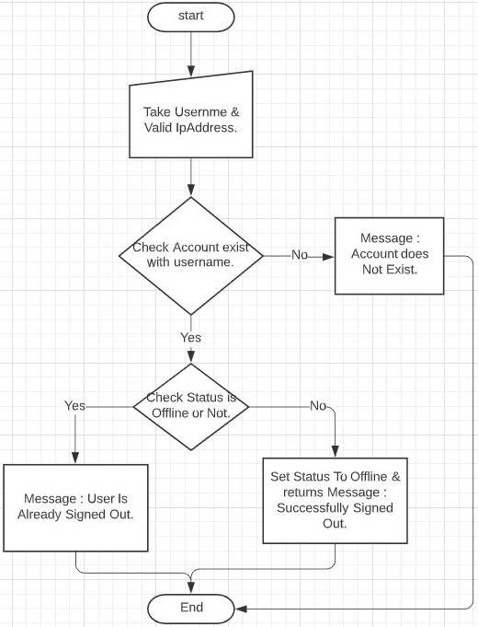

**(Note:** For Transfer Account and Get player status operations the way it works is described in UDP description above where it takes required inputs from user and verifies them and if all valid it will send particular UDP request to other server(s) based on operation. Then server will perform operation based on received request and returns result to server who sent request and then these results are returned to client and also written into log files.)

1. **Suspend Player Account.**

* While Administrator want to suspend player account program will verify Admin account credentials and if they are valid it will take username of player account which he wants to suspend and valid IpAddress as input. Then on the server first it will check if there exist a player account with entered username or not. If there is no such a player account with that username it will return message that player account not exist. Otherwise if player account exist it will remove it from HashMap and return success message. Message will be return to user as well as it will be written in Log Files.

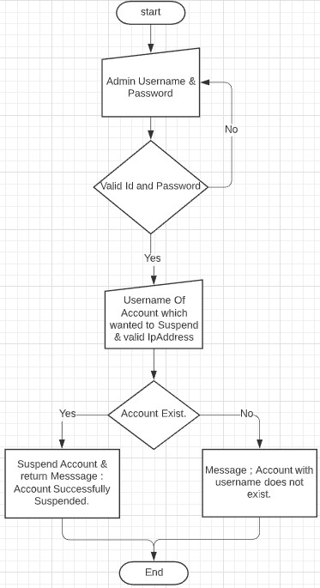

* **Test Cases:**

1. **Validations (All attributes must be entered & can’t be empty)**

* **First Name** and **Last Name** Should Contain Only Alphabets without any Whitespaces.

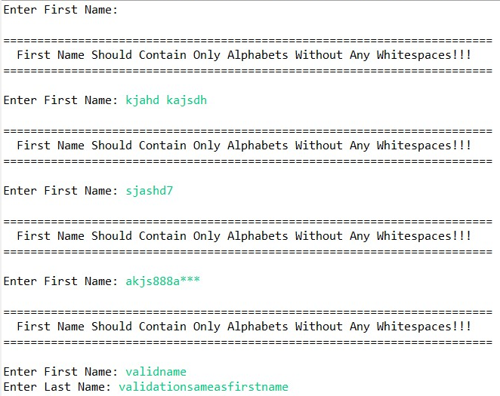

* **Age** must be Positive Integer without any whitespaces.

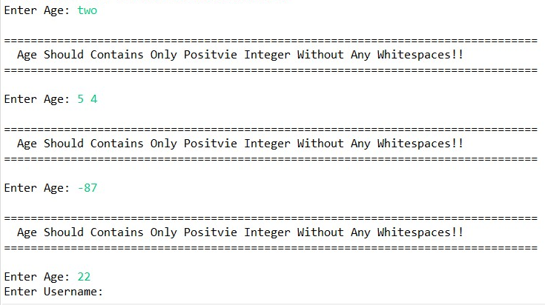

* **Username** must be start with alphabet and should not contain any whitespaces and length must be minimum of 6 and maximum of 15 characters.

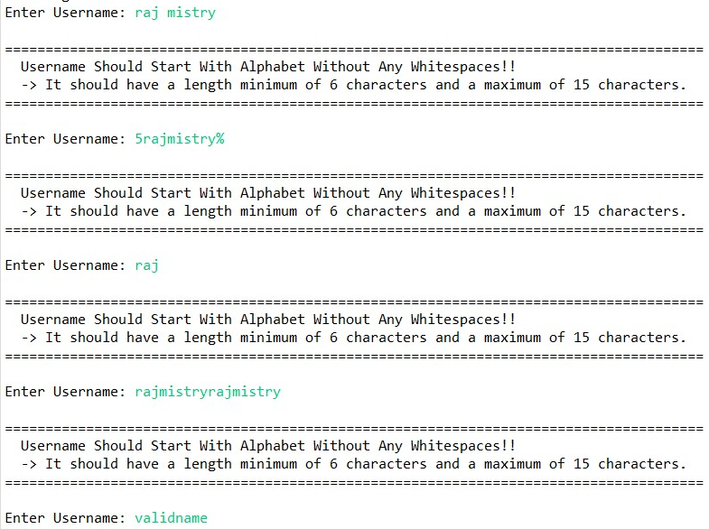

* **Password** must not contain any whitespaces and should have minimum length of 6 characters.

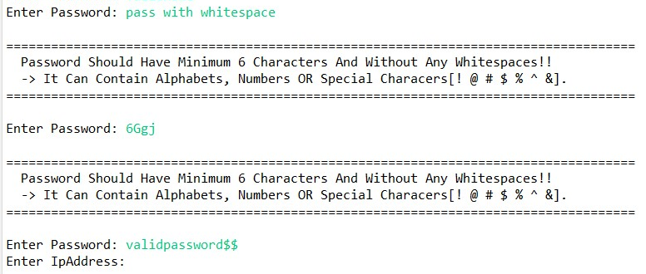

* **IP Address** must be entered as per valid IPv4 format & must be entered from one of the 3 ranges (132.xxx.xxx.xxx, 93.xxx.xxx.xxx, 182.xxx.xxx.xxx)

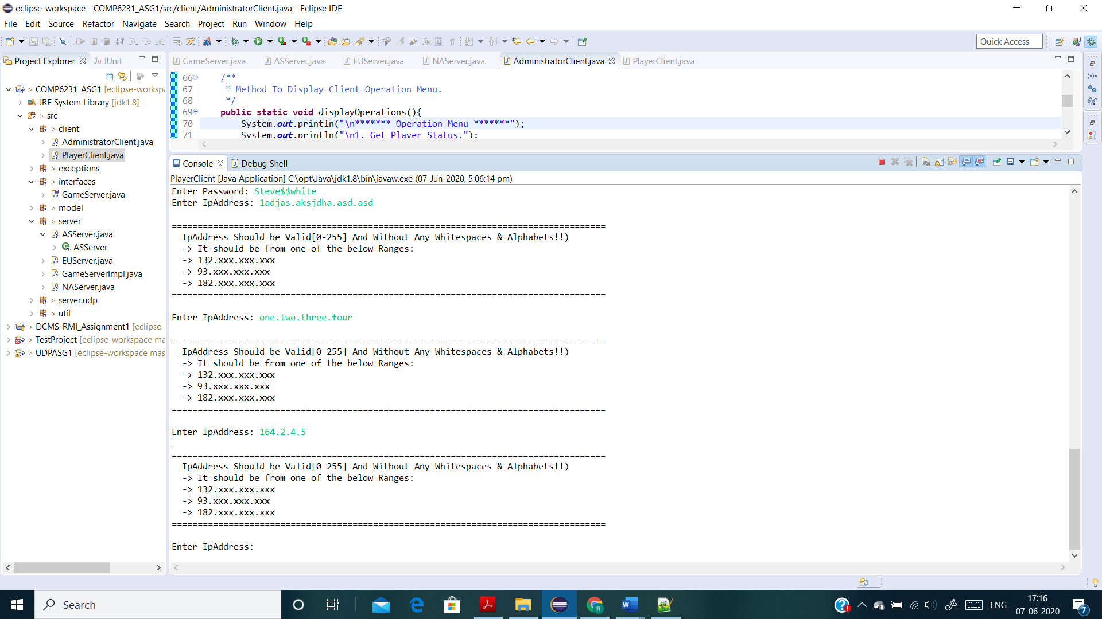

* **New IP Address for transfer Account** must be different from old Ip Address as Account cannot be transfer to same server & it must be entered as per valid IPv4 format & must be entered from one of the 3 ranges (132.xxx.xxx.xxx, 93.xxx.xxx.xxx, 182.xxx.xxx.xxx).

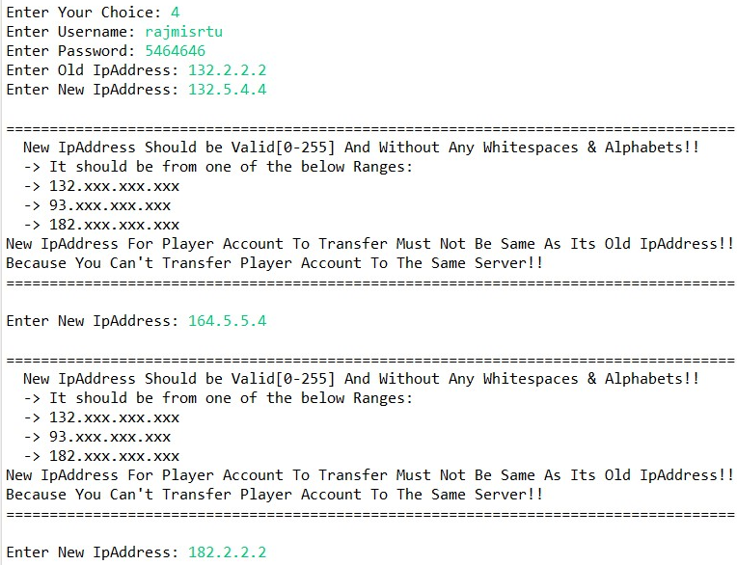

* **Username and Password for Administrator** must be “Admin” without any whitespaces and must be exact same as shown (Case Sensitive).

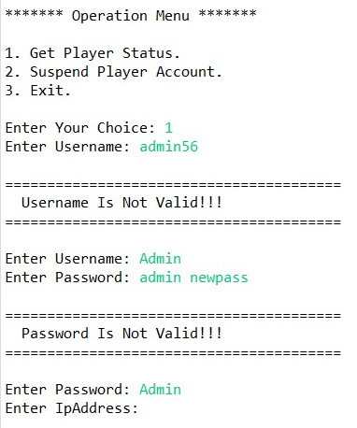

1. **Create New Player Account (Successfully Created New Player Account)**

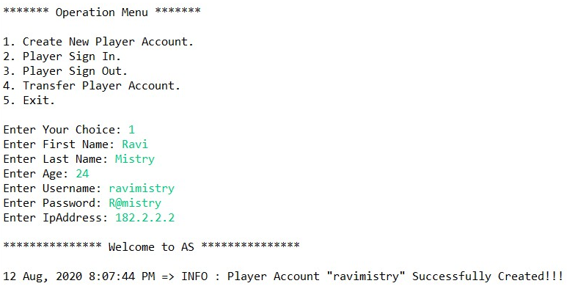

1. **Create New Player Account (Unsuccessful – Player Account with same username Already Exist)**

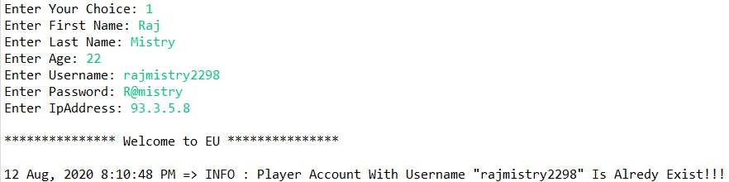

1. **Player Sign In (Unsuccessful - Player Account in which trying to Sign In Not Exist)**

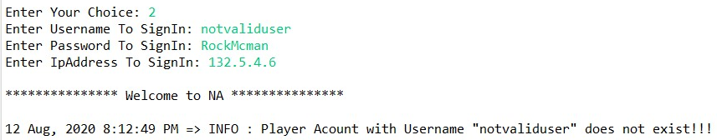

1. **Player Sign In (Unsuccessful - Wrong Password Entered For Player Account to Sign In)**

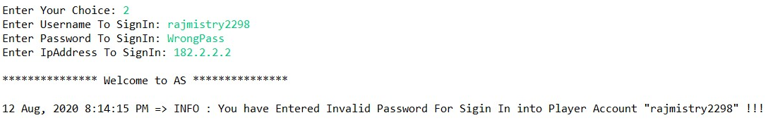

1. **Player Sign In (Successfully Signed in into Player Account)**

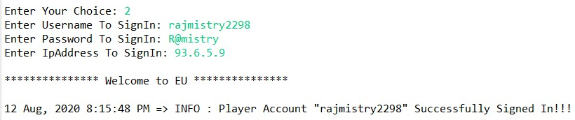

1. **Player Sign In (Trying to sign in into Player Account which is Already Signed In)**

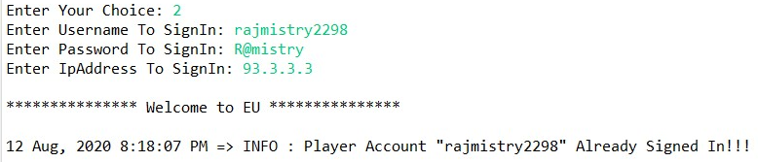

1. **Player Sign Out (Unsuccessful - Player Account from which trying to Sign Out Not Exist)**

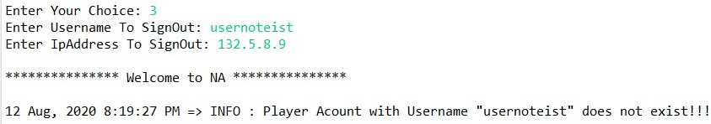

1. **Player Sign Out (Player Account Successfully Signed Out)**

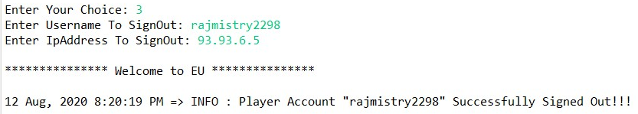

1. **Player Sign Out (Player Account Trying To Sign Out Which Is Already Signed Out)**

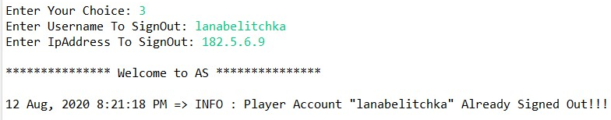

1. **Transfer Player Account (Unsuccessful – Player Account which client trying to transfer does not exist on server)**

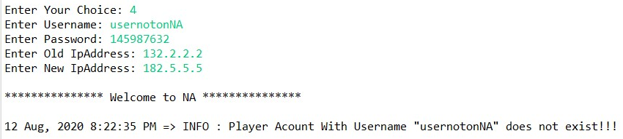

1. **Transfer Player Account (Unsuccessful – Player Account which client trying to transfer is exist on server but wrong password is entered for Account)**

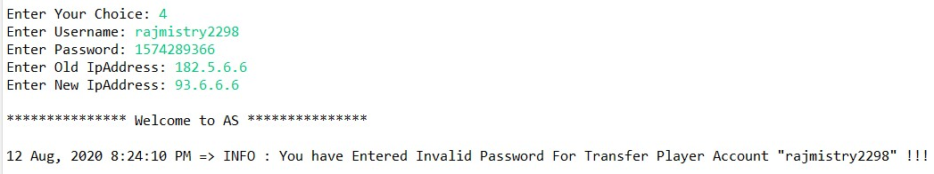

1. **Transfer Player Account (Unsuccessful – Player Account which client trying to transfer, Player Account with same username already exist on destination server)**

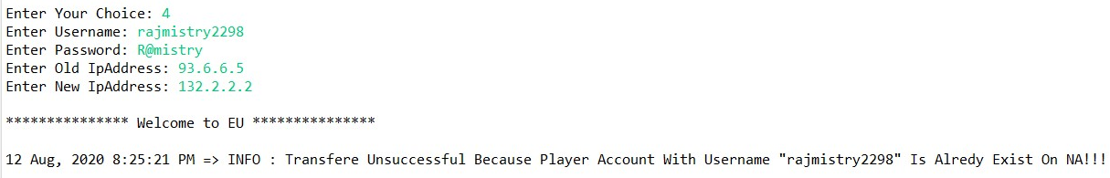

1. **Transfer Player Account (Successful – Player account exist and valid password and account with same username not exist on destination server.)**

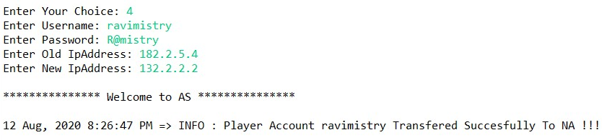

1. **Administrator Get Player Status.**

**Initially each server has 5 Player Accounts:**

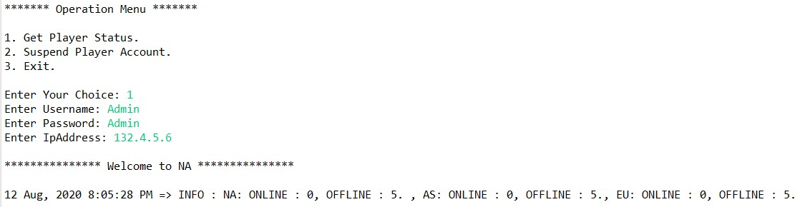

**After Creating One Player Account On Asia Server by playerClient:**

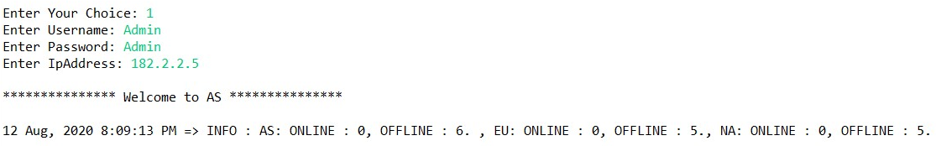

**After One Player Account Signed In at Europe Server by playerClient:**

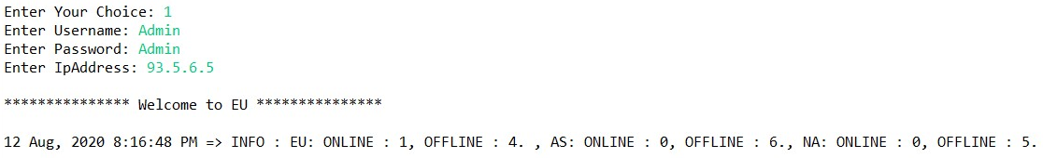

**After Transferring 1 Player Account from Asia Server to North-America Server.**

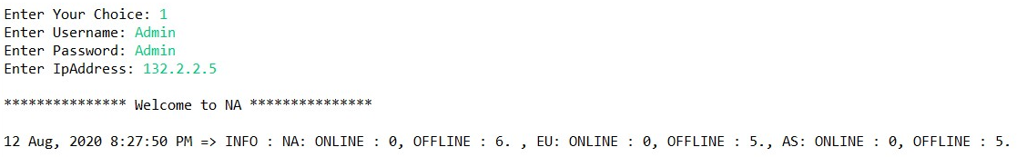

1. **Suspend Player Account.**

**Unsuccessful – Player Account with entered username not exist on server.**

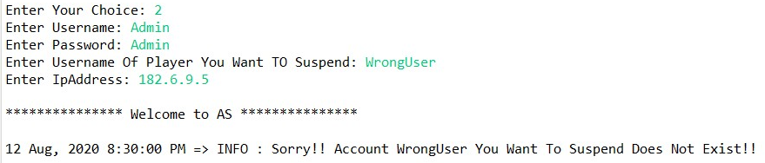

**Suspend Player Account successfully.**

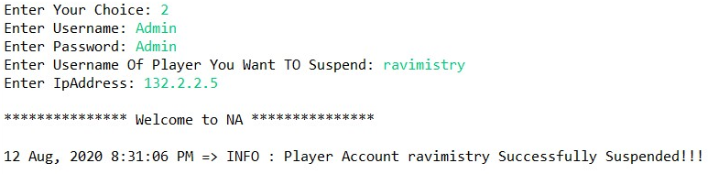

**Player Status after Suspending One Account from NA server.**

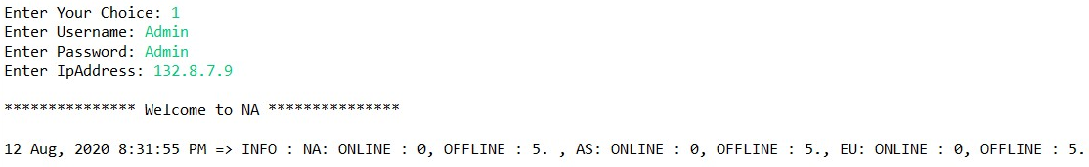

**Try to sign in into player account which was suspended by Admin.**

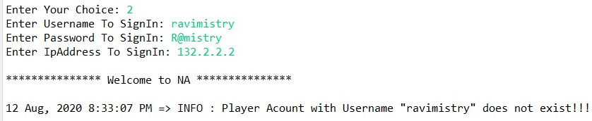

1. **Multithreaded Test For Checking Concurrency and Atomicity for Transfer Account And Suspend Account.**

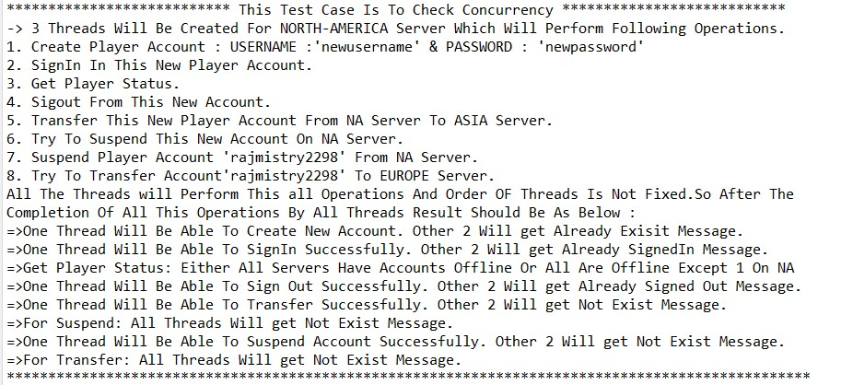

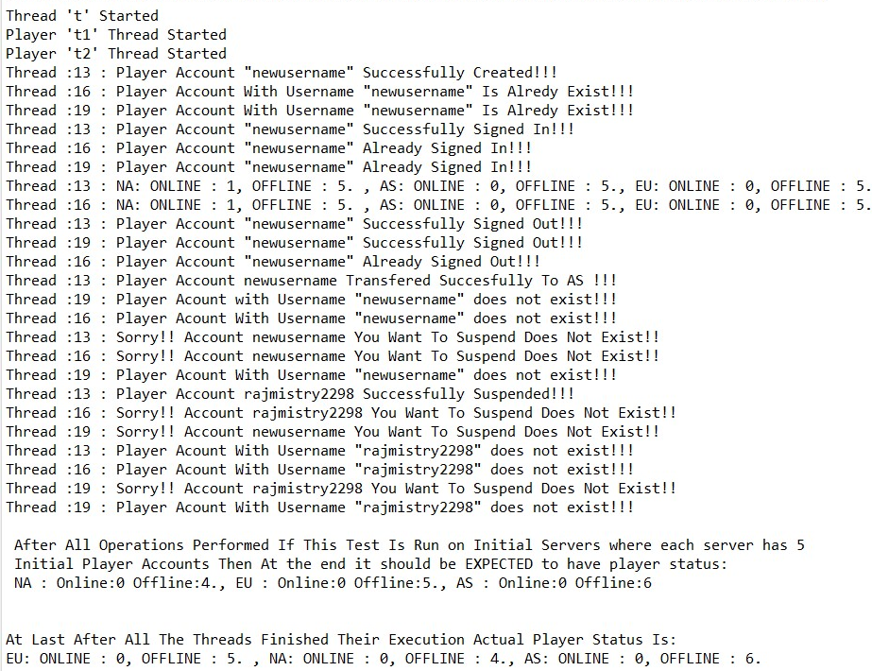

1. **Byzantine Error:** Here I have Implemented Byzantine error Test scenario on replica 3 on request number 4, 5 & 6 (It will be printed by Leader but client will get correct result). At Request number 6 it will be 3rd successive byzantine error. So Leader will inform Replica Manager 3. After that Replica Manager 3 will send message to Replica Manager 2 to give correct Data. So, RM 2 will inform its 3 servers to send correct data to RM 3, then RM 3 will send this to its particular server.

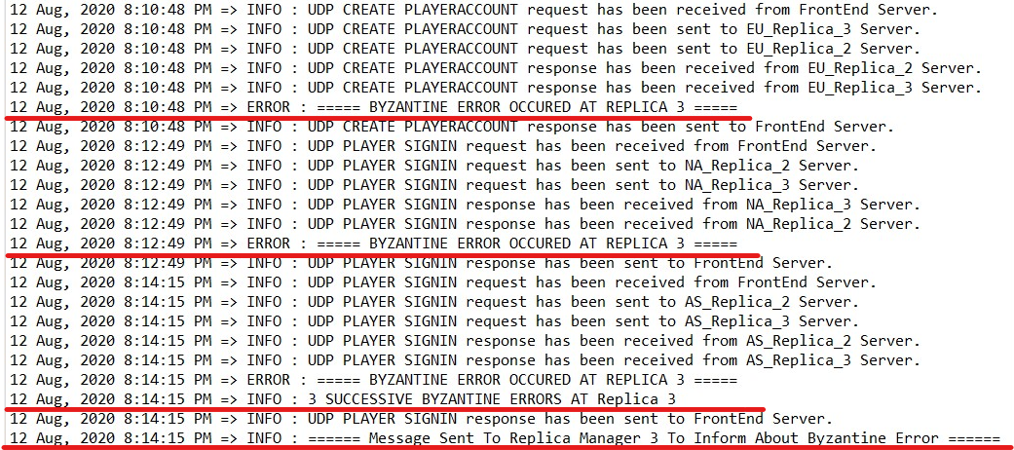

**\*Leader Got 3 Successive Byzantine Errors From Replica 3 & Informed To RM3\***

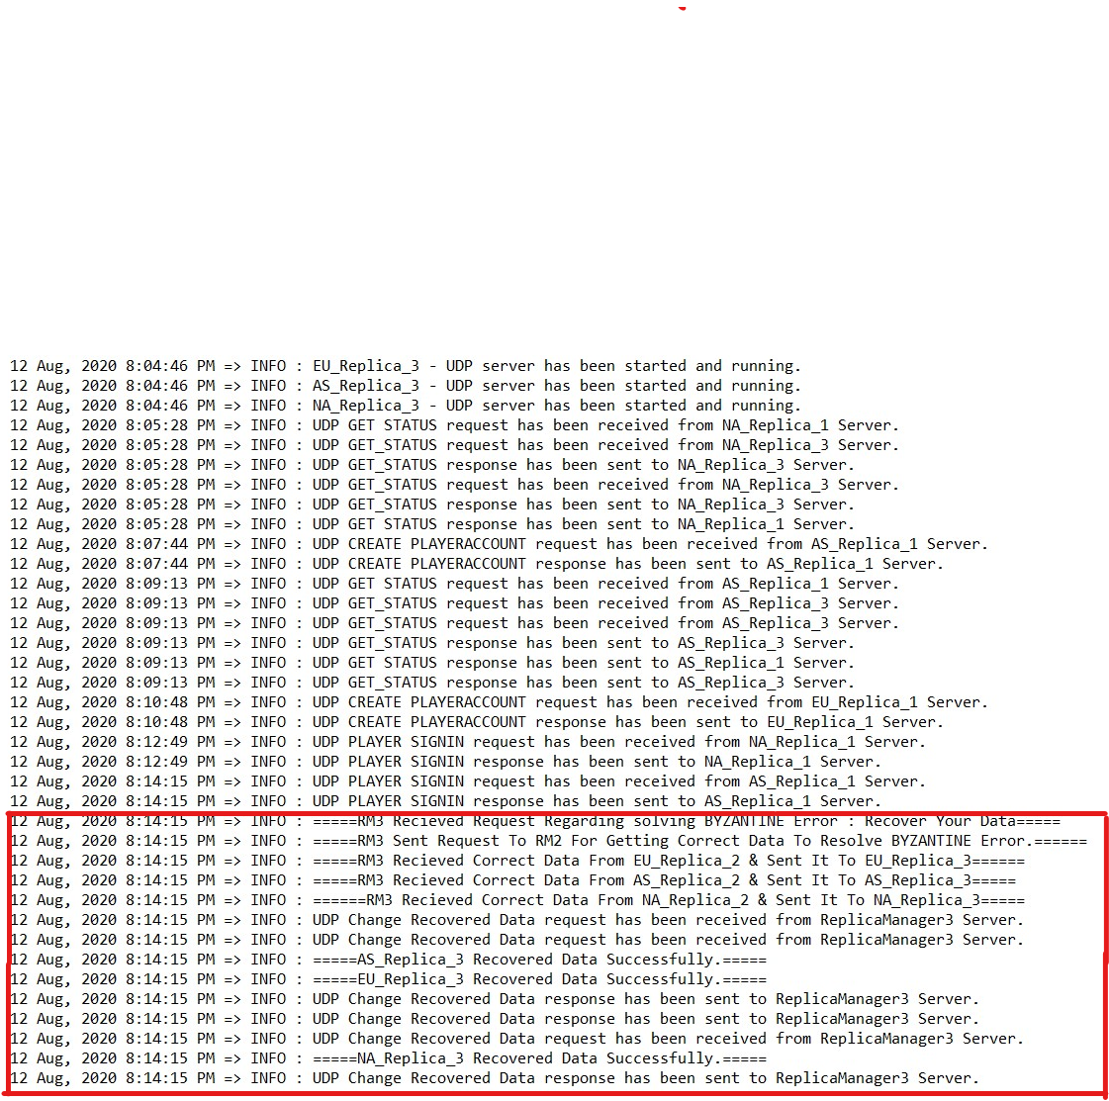

**\*RM3 Got Byzantine Error Info & Recovered data from RM2\***

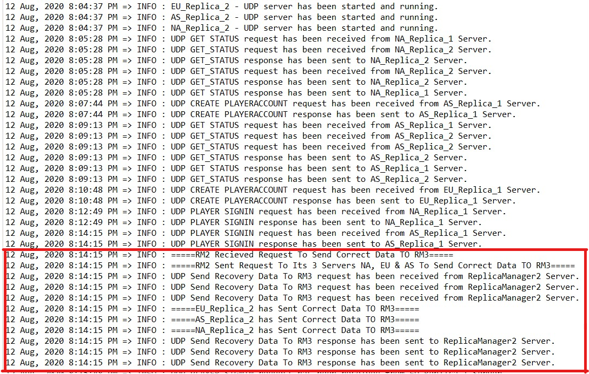

**\*RM2 Got Request To Send Correct Data From RM3\***

1. **UDP Reliability Test:** Here is test for UDP reliability. As mentioned above that if FrontEnd not get any response from Leader, it will wait for 5 seconds and resend request. It will send Maximum 3 times after that if it not get response then it will give response to client that no response from server so that client not wait forever.

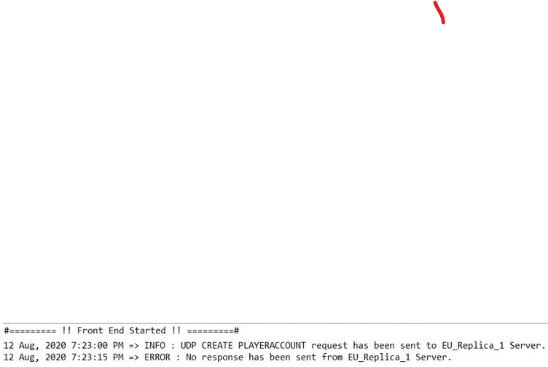

**\*FrontEnd\***

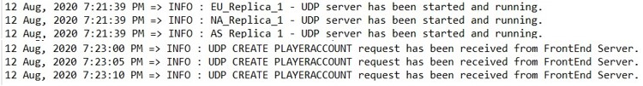

**\*Leader (Replica 1)\***

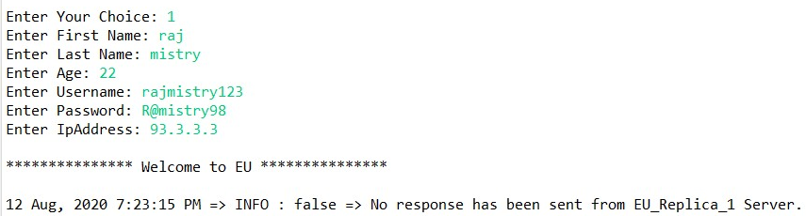

**\*Client\***

* **Challenges (Most Important / Difficult Part):**

1. Managing concurrency between 3 replicas.
2. FIFO Implementation & make UDP reliable.
3. Implementing synchronization among shared data and avoiding deadlocks.
4. Byzantine Error Implementation.

* **References:**
* http://bedford-computing.co.uk/learning/wp-content/uploads/2016/03/george-coulouris-distributed-systems-concepts-and-design-5th-edition.pdf
* <https://en.wikipedia.org/wiki/Common_Object_Request_Broker_Architecture>
* <https://en.wikipedia.org/wiki/Interface_description_language>
* <https://en.wikipedia.org/wiki/Object_request_broker>
* <https://www.corba.org/orb_basics.htm>
* <https://research.cs.queensu.ca/home/xiao/DS/node5.html>
* <https://www.geeksforgeeks.org/countdownlatch-in-java/>
* <https://docs.oracle.com/javase/8/docs/api/java/util/concurrent/ConcurrentLinkedQueue.html>
* <https://stackoverflow.com/questions/9580457/fifo-class-in-java>
* <https://stackoverflow.com/questions/24085571/synchronizing-queue-in-java-on-multiple-threads>